**Exercise 7: Financial Forecasting**

**Scenario:**

You are developing a financial forecasting tool that predicts future values based on past data.

**Steps:**

1. **Understand Recursive Algorithms:**
   * Explain the concept of recursion and how it can simplify certain problems.
2. **Setup:**
   * Create a method to calculate the future value using a recursive approach.
3. **Implementation:**
   * Implement a recursive algorithm to predict future values based on past growth rates.
4. **Analysis:**
   * Discuss the time complexity of your recursive algorithm.
   * Explain how to optimize the recursive solution to avoid excessive computation.

**ANSWER 1 : -**

Recursion is a programming technique where a function calls itself to solve a problem by breaking it down into smaller, similar subproblems. Recursive algorithms are particularly useful for problems that have a natural hierarchical or repetitive structure, such as time series forecasting, where each future value depends on previous values. Recursion can simplify code and make complex problems more manageable by expressing them in terms of simpler, self-similar tasks.

**ANSWER 2 : -**

A method to calculate the future value using a recursive approach.

*FV*=*PV*×(1+*r*)^*n*

Where:

* *FV* = future value
* *PV* = present value
* *r* = growth rate per period
* *n* = number of periods

**ANSWER 3 (CODE) : -**

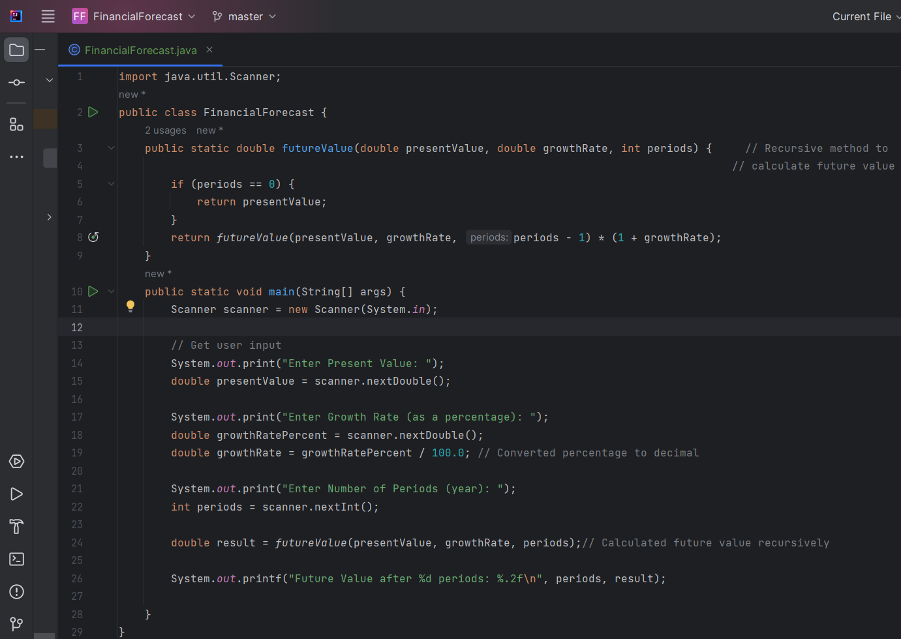

**OUTPUT : -**

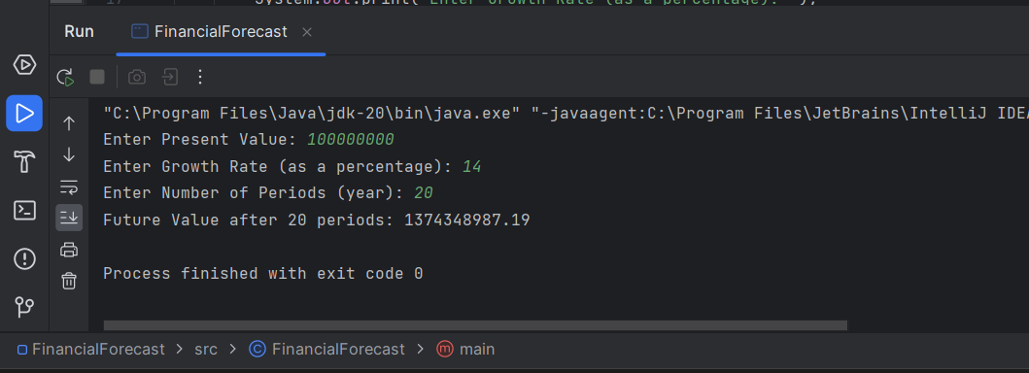

**ANSWER 4 : -**

1. Use an Iterative Approach

* Replace recursion with a loop. This reduces stack usage to O(1) and avoids function call overhead.
* Example: Use a for-loop to multiply the value over each period.

2. Use the Closed-form Formula

* For compound growth, the closed-form formula (FV=PV×(1+r)^n)computes the result in O(1)time, making it the most efficient solution.